

I was getting below error

source ~/.bashrc

Command 'shopt' not found, did you mean:

command 'shout' from deb libshout-tools

Try: apt install <deb name>

Command 'shopt' not found, did you mean:

command 'shout' from deb libshout-tools

Try: apt install <deb name>

Command 'shopt' not found, did you mean:

command 'shout' from deb libshout-tools

Try: apt install <deb name>

Command 'shopt' not found, did you mean:

command 'shout' from deb libshout-tools

Try: apt install <deb name>

complete: command not found

complete: command not found

complete: command not found

complete: command not found

complete: command not found

complete: command not found

complete: command not found

complete: command not found

complete: command not found

complete: command not found

/usr/share/bash-completion/bash_completion:1590: parse error near `|'

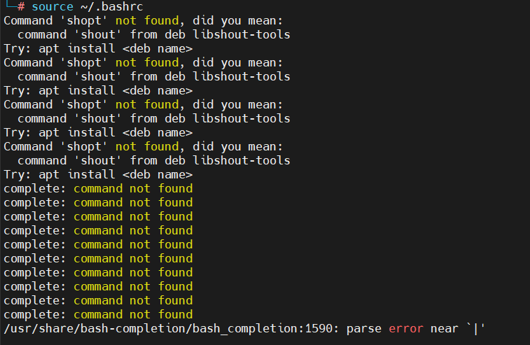

I just executed bash command on terminal.

